Libspace backend system
Ideation Phase
Brainstorm & Idea Prioritization

Date | 07:03:2026
Team ID | SWTID-2026-3081
Project Name | LibSpace
Maximum Marks | 4 Marks

Brainstorm & Idea Prioritization – Libspace Backend System
Brainstorming was conducted to identify the most effective backend solution for managing a digital book system. During the ideation phase, the focus was on designing a secure and scalable backend application that handles user authentication and book management operations.
Ideas were evaluated based on:

- Feasibility within the development timeline
- Backend architecture clarity
- Security implementation
- REST API best practices
- Learning outcomes and resume value

Step -1: Team Gathering, Collaboration and Selecting the Problem Statement :

The team conducted a discussion session to identify backend-focused project ideas that could demonstrate strong understanding of authentication, database management, and RESTful API design.
Several backend project ideas were proposed:
- Library Management System
- Blog API System
- Student Record Management System
- Task Manager API
- Book Rental System
After evaluating real-world applicability, technical feasibility, and alignment with backend development learning goals, the team finalized the following problem statement:

Problem Statement:
Many small libraries, study groups, and individual users lack a simple and secure backend system to manage books digitally. Existing systems are often overly complex or include unnecessary features.
Therefore, the team decided to build Libspace, a backend-based Book Management System that allows users to:

- Register and login securely
- Manage books using CRUD operations
- Access only their own book records
- Logout securely
The system focuses on implementing secure authentication and structured REST APIs.

Step-2: Brainstorm, Idea Listing and Grouping :
During brainstorming, all ideas were listed without restriction. The ideas were then grouped into logical backend modules.

Authentication & Security Ideas :

- User registration with validation
- JWT-based login authentication
- Secure password hashing using bcrypt
- Protected routes using middleware
- Token expiration handling
- Logout mechanism using token invalidation

Core Book management Features :
. Add new book
- Update book details
- Delete book
- View all books
- Fetch single book by ID
- Pagination for book listing (optional enhancement)

Database & Architecture Ideas :
. Relational / NoSQL database design
- Users table/collection
- Books table/collection
- Foreign key or user reference mapping
- Proper indexing for performance
- RESTful API structure

Backend Technical Implementation Ideas :

- MVC architecture
- Middleware-based route protection
- Centralized error handling
- Status code standardization
- Input validation layer
- Environment variable configuration
After grouping, the team focused on ideas that could be realistically implemented within the project timeline while maintaining backend best practices.

Step-3: Idea Prioritization :
The team prioritized features based on:

- Feasibility within deadline
- Backend learning value
- Real-world backend implementation relevance
- Security importance
- Technical complexity

High Priority (Implemented Features) :

- User Registration
- User Login with JWT Authentication
- Password hashing using bcrypt
- Protected API routes
- CRUD operations for books
- Database integration
- Logout functionality

Medium Priority (Enhancements) :

- Pagination for books
- Advanced validation
- Improved error handling responses
- API documentation (Swagger/Postman collection)

Low Priority / Future Scope :

- Role-Based Access Control (Admin/User)
- Book categories & tagging
- Rate limiting
- Audit logging
- Deployment on cloud server
- API versioning

Final Decision :
The team finalized Libspace – Backend Book Management System as it provides strong learning opportunities in:

- JWT-based authentication
- Secure backend development
- REST API design
- Database schema design
- Middleware implementation
- Backend security best practices
The project focuses entirely on backend development, ensuring clean architecture, secure authentication flow, and structured CRUD operations

Libspace backend system
Ideation Phase
Define the Problem Statements

Date | 07:03:2026
Team ID | SWTID-2026-3081
Project Name | LibSpace
Maximum Marks | 2 Marks

Customer Problem Statement – Libspace Backend System
The Customer Problem Statement helps identify the challenges faced by users while managing books in a digital system. Understanding the user's perspective allows the team to design a backend application that is secure, structured, and efficient.
Many small libraries, students, and individual users struggle to manage book records manually or through unorganized digital methods. Existing systems are often:
- Overly complex
- Paid or subscription-based
- Not secure
- Lacking proper user-specific data access
- Difficult to maintain
There is a need for a simple and secure backend system that allows users to manage books efficiently while ensuring data privacy and authentication control.

Identified User Challenges :
- Lack of secure authentication mechanisms
- No centralized system to store and manage books
- Inability to restrict access to user-specific data
- Difficulty in updating and deleting records
- Risk of data inconsistency or duplication

Customer Needs :
Users require a system that:

- Allows secure user registration and login
- Ensures passwords are encrypted and protected
- Restricts access to authorized users only
- Provides full CRUD operations for books
- Maintains proper database structure
- Ensures reliable error handling

Project Focus Based on Customer Needs :
To address these challenges, the team decided to build Libspace – Backend Book Management System, which:
- Implements JWT-based authentication
- Provides secure login and logout functionality
- Enables users to perform CRUD operations on books
- Ensures user-specific data isolation
- Follows RESTful API standards
- Implements middleware for route protection

Outcome of the Customer Problem Analysis :
By analyzing customer pain points, the project focuses on delivering:
- Secure backend architecture
- Structured database management
- Clean API design
- Scalable system foundation
- Real-world backend implementation practices
The ideation phase ensured that the system is not just technically functional but also aligned with real user problems and practical backend development goals.
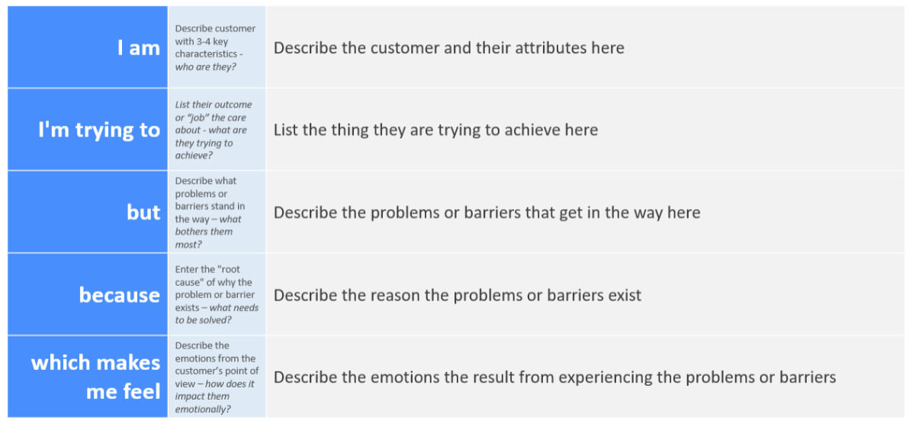Reference: https://miro.com/templates/customer-problem-statement/
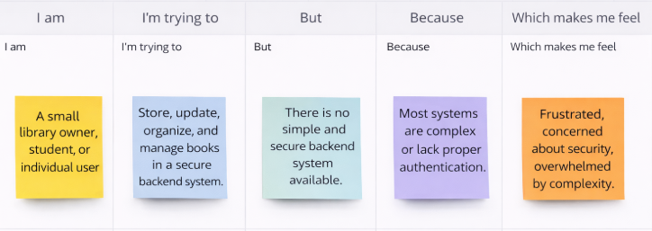

Problem Statement | I am (Customer) | I’m trying to | But | Because | Which makes me feel
PS-1 | A small library owner | Manage and organize book records digitally | Existing tools are complex or require paid subscriptions | I need a simple backend system to securely add, update, and delete books | Frustrated managing records manually
PS-2 | A student managing personal books | Keep track of books in one centralized system | There is no secure system that restricts access to my data | I want a login-based system where only I can manage my books | Concerned about data privacy
PS-3 | A individual user | Update and delete book information easily | Many systems do not provide proper authentication or data isolation | I need a secure backend with JWT authentication and protected routes | Anxious about unauthorized access
PS-4 | A beginner user with limited technical knowledge | Use a simple system to manage books without complexity | Most available platforms focus more on UI and less on backend security | I want a lightweight and secure system that is easy to use | Overwhelmed by complicated software

LibSpace- backend system
Ideation Phase
Empathize & Discover

Date | 07:03:2026
Team ID | SWTID-2026-3081
Project Name | LibSpace
Maximum Marks | 4 Marks

Empathy Map Canvas :
An empathy map is a simple, easy-to-digest visual that captures knowledge about a user’s behaviours and attitudes.

It is a useful tool to helps teams better understand their users.
Creating an effective solution requires understanding the true problem and the person who is experiencing it. The exercise of creating the map helps participants consider things from the user’s perspective along with his or her goals and challenges.
Example :

